Place the Title of Your Document Here, Centered, Single-Spaced if
More than One Line

by

Your Name

Your First Degree
Name of Granting Institution, Year Received

Your Second Degree (if any)
Name of Granting Institution, Year Received

Submitted in Partial Fulfillment of the Requirements

For the Degree of insert your degree here in

your major

your college

University of South Carolina

year of graduation

Accepted by:

name, Major Professor OR Director of Thesis

name, Committee Member OR Reader

name, Committee Member OR Reader

name, Committee Member OR Reader

Ann Vail, Dean of the Graduate School
© Copyright by insert your name, year of graduation
All Rights Reserved.
Dedication
Including a Dedication is optional. In this space, enter the body of your dedication. It should be no longer than one page. This text should be double-spaced, 12-point font (in Arial, Calibri, Courier New, Palatino, Tahoma, or Times New Roman), and either left- or fully-justified.
Acknowledgements
This page is also optional. In this space, enter the body of your acknowledgements. It should be no longer than one page except in unusual cases. This text should be double-spaced, 12-point font (in Arial, Calibri, Courier New, Palatino, Tahoma, or Times New Roman), and either left- or fully-justified.
Abstract
This page is not optional – your document must have an abstract. In this space, enter the body of your abstract. The abstract is a succinct statement of the significant contents of the manuscript and the value and relevance of the study. Generally, it should be no longer than 350 words. Your abstract should be double-spaced, 12-point font (in Arial, Calibri, Courier New, Palatino, Tahoma, or Times New Roman), and either left- or fully-justified.
Preface
This page is optional. In this space, enter the body of your preface. This text should be double-spaced, 12-point font (in Arial, Calibri, Courier New, Palatino, Tahoma, or Times New Roman), and either left- or fully-justified.
Table of Contents
Dedication iii
Acknowledgements iv
Abstract v
Preface vi
List of Tables viii
List of Figures ix
List of Symbols x
List of Abbreviations xi
Chapter 1: If the Chapter Title is Longer Than One Line,
Single-Space to the Next Line 1
Chapter 2 Title 3
References 6
Appendix A: Title 8
List of Tables
Table 2.1 Place table name here 7
Table 2.2 Place table name here 9
Table 3.1 Place table name here 22
Table 3.2 Place table name here 24
Table 3.3 Place table name here 29
Table 4.1 Place table name here 33
List of Figures
Figure 2.1 Place figure name here 4
Figure 2.2 Place figure name here 10
Figure 3.1 Place figure name here 23
Figure 3.2 Place figure name here 25
Figure 3.3 Place figure name here 30
Figure 4.1 Place figure name here 34
List of Symbols
J Resultant total angular momentum quantum number, excluding nuclear spins.

N Rotational angular momentum quantum number, excluding electron and nuclear spins, in the case where electron spin is present.

K Projection of J (or N) on the symmetry axis in the limiting prolate or oblate symmetric top.

F₁ Resultant angular momentum quantum number including nuclear spin for one nucleus.

F Resultant total angular momentum quantum number.

λ or Quantum number employed when F₁ is not a good quantum number. This value
ϵ simply numbers the levels from lowest to highest energy for the same F quantum
number.
List of Abbreviations
AC Active Case Detection
ACR Adequate Clinical Response
CDRI Central Drug Research Institute
ETF Early Treatment Failure
IRS Indoor Residual Spraying
LTF Late Treatment Failure
MDR Multidrug Resistance
CHAPTER 1
Introduction
In August 2006, then-White House Press Secretary Tony Snow revealed that President George W. Bush had been reading Albert Camus’ famous novel, The Stranger, while vacationing at his ranch in Crawford, Texas. When asked to comment, Snow said that President Bush “found it an interesting book and a quick read” and that he and the President had discussed its meaning. “I don’t want to go too deep into it,” Snow explained, “but we discussed the origins of existentialism” (Dickerson 2006).
Satirists seized upon the otherwise trivial news item for its offerings of political humor. Lee Siegel blended Bush’s no-nonsense rhetoric with the terse ‘American’ style Camus used to fashion the memorable voice of Meursault, fusing the two figures together in his New Republic article entitled “Strangerer” (Siegel 2006), while writers with more of a political axe to grind reveled in the ironic contrast between Bush’s and Camus’ positions on just about everything, from religious faith to the use of military force to capital punishment. One might be surprised that sharper contrasts were not drawn between the President who dubbed himself ‘the decider’ and Camus’ Meursault, who decides next to nothing. The closest anyone came to making such a comparison was apparently in the vague suggestion floating around the Press Room that the President was going through an ‘existential’ foreign-policy crisis. Tony Snow reportedly (and somewhat tastelessly) rebuffed this suggestion by insisting that “he [the President] doesn’t feel like an existentialist trapped in Algeria during the unpleasantness” (Dowd 2006).
A few writers who were familiar with Camus’ work understood that the greatest irony of all was the discomfiting parallel between the racial and colonial violence between the lines of The Stranger and America’s questionable and controversial war in Iraq. While not all were familiar with Conor Cruise O’Brien’s or Edward Said’s scathing critiques of Camus’ colonialism, John Dickerson understood that Bush’s taking-up of the novel was ripe for “geopolitical literary misinterpretation” (2006). Half-sarcastically concerned that a Camus-Bush connection would be misunderstood in the Middle East and around the world, Dickerson proclaimed it to be “the first time that national security demand[ed] an official version of literary criticism” (2006).
Putting aside concerns about national security and international perception for a moment, it is curious that this otherwise insignificant Presidential tidbit aroused so much fascination. The rest of the President’s summer reading list, which reportedly included a study of Robert Oppenheimer and a biography of Abraham Lincoln (meaning the President was reading about absurdity, atomic weapons, and a divided nation all at once), made less of a media splash (Gopnik 2006). A few critics were offended by what they saw as a misguided attempt by the White House to bolster Bush’s image as an intellectual, but I think the fascination that the story sparked within the country was profound and enlightening in terms of people’s interest in the more mundane facets of the president’s personal life instead of his actual efforts on the geopolitical front.
CHAPTER 2
A Brief History of the Philosophy of the Absurd
Our present confusion about the absurd results not only from a lack of attention to Camus’ theoretical contribution, to which all but one of the following chapters of this work are addressed, but from the many competing philosophical understandings of absurdity, which I review here. In ordinary language, we use the word ‘absurd’ interchangeably with ‘incongruent’, ‘irrational’, ‘senseless’, and ‘ridiculous’, but these synonyms stand in an unclear and uncomfortable relation to the philosophical meanings of the term. In fact, in standard dictionaries, ‘absurd’ is often given two or more separate meanings. The first is generally that which is “utterly or obviously senseless, illogical, or untrue… laughably foolish or false,” while the second is “the quality or condition of existing in a meaningless or irrational world” (Random House Webster’s College Dictionary 1991). This humorous double-sense of ‘absurd’ suggests that even the word may be charged with a kind of ambivalence, a tension between comedy and tragedy, laughter and despair (Figure 2.1).
The word ‘absurd’ is actually derived from the Latin absurdus, which means “out of harmony,” what is unharmonious to the ear (see Esslin 2001, 23), but its likely root is not surd, meaning ‘deaf’, but svar, meaning ‘tune’ or ‘sound’ (Halsey 1882, 151). While this chapter refers to Camus’ work, its goal is to briefly treat other absurd theorists in order to highlight key themes and debates within the development of absurd thought and to give the reader a sense of the various interpretations of absurdity, which are perhaps as
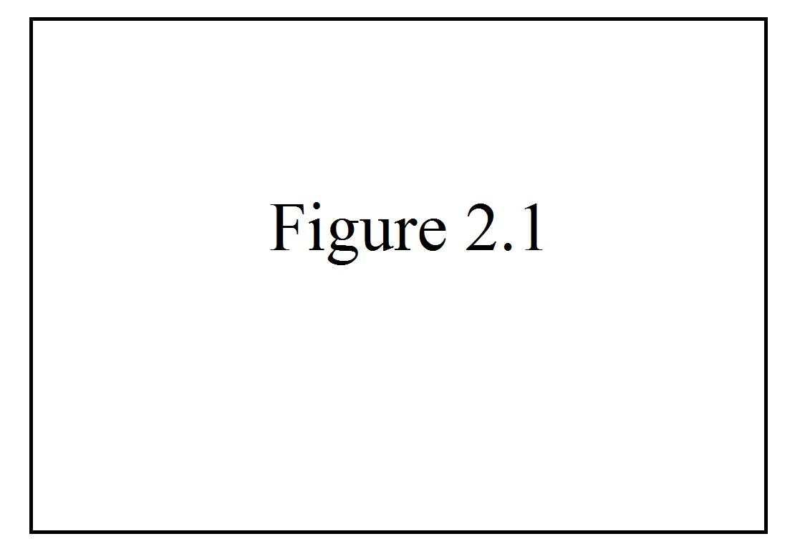
Figure 2.1 Type the caption of your figure here. Refer to the Formatting Guide for specific instructions regarding tables and figures.
discordant as the etymology of the term implies. Because the absurd remains such a muddled concept, attempts to trace its heritage have had only the most limited success. To give but one example, John Cruickshank sees in Camus’ absurd “a contemporary manifestation of a scepticism as old at least as the Book of Ecclesiastes” (Cruickshank 1960, 44). But Cruickshank’s equation of both Ecclesiastes and absurdity with skepticism seems strangely shortsighted for such a thoughtful critic. Most studies have focused, instead, on the absurdity inherent in Qohelet’s key word, hebel, translated often as ‘vanity’, but which literally denotes ‘breath’, ‘breeze’, or ‘vapor’ (see Fox 1989, 29; Fredericks 1993, 12n; Dor-Shav 2004; Berger 2001). These studies have argued that the sense of the term, and of that key phrase which so often follows it, reut-ruah, or ‘chasing after wind’ (Jastrow 1919, 204n), are not far from the contemporary notion of absurdity. Unfortunately, very few of these studies have been clear about what that contemporary notion of absurdity entails.
2.1 SUB-SECTION
Michael Fox’s study of Ecclesiastes specifically unites Qohelet’s words with Camus’ absurd philosophy and makes a detailed argument for the relationship between the two. “The best translation-equivalent for hebel in Qohelet’s usage,” says Fox, “is ‘absurdity’, understood in a sense and with connotations close to those given the concept in Albert Camus’s classic description of the absurd, The Myth of Sisyphus” (1989, 31).
2.2 SUB-SECTION
What is lacking in Fox’s account of this relationship, however, is a thorough examination of the concept of the absurd, itself.
References
Abecassis, Jack. 1997. Camus’s pulp fiction. French issue, MLN 112 (4): 625-640.
Abel, Donald. 1989. Freud on instinct and morality. Albany: State University of New
York Press.

Alford, C. Fred. 1989. Melanie Klein and critical social theory: An account of politics,
art, and reason based on her psychoanalytic theory. New Haven, CT: Yale
University Press.

———. 1999. A psychoanalytic study of evil. American Imago 56 (1): 27-52.

———. 2005. Rethinking freedom: Why freedom has lost its meaning and what can be
done to save it. New York: Palgrave Macmillan.

Alvarez, Michael and J. Brehm. 2002. Hard choices, easy answers: Values, information,
and American public opinion. Princeton, NJ: Princeton University Press.

Anthony, E. James. 1987. Risk, vulnerability, and resilience: An overview. In The
Invulnerable Child, ed. E.J. Anthony and B. Cohler, 3-48. New York: Guilford.

Apter, Emily. 1997. Out of character: Camus’s French Algerian subjects. French issue,
MLN 112 (4): 499-516.

Archambault, Paul. 1972. Camus’ Hellenic sources. Chapel Hill: University of North
Carolina Press.

Arendt, Hannah. 1958. The human condition. Second ed. Chicago: University of
Chicago Press.

Arias-Bolzman, Leopoldo, G. Chakraborty, and J. Mowen. 2000. Effects of absurdity
in advertising: The moderating role of product category attitude and the
mediating role of cognitive responses. Journal of Advertising 29 (1): 35-49.

Aronson, Ronald. 2004. Camus and Sartre: The story of a friendship and the quarrel
that ended it. Chicago: University of Chicago Press.

Augustine. 1961. Confessions. Trans. R.S. Pine-Coffin. London: Penguin.

Balogun, F. Odun. 1984. Characteristics of absurdist African literature: Taban lo
Liyong’s Fixions — a study in the absurd. African Studies Review 27 (1): 41-55.

Bauman, Zygmunt. 1992. Survival as a social construct. In Cultural theory and cultural
change, ed. M. Featherstone, 1-36. London: Sage.

Beckett, Samuel. 1956. Waiting for Godot: a tragicomedy in two acts. First Evergreen ed.
New York: Grove Weidenfeld.

———. 1958. Endgame: A play in one act — followed by — Act without words: A mime
for one player. New York: Grove Press.

Benjamin, Lorna. 1993. Interpersonal diagnosis and treatment of personality disorders.
New York: Guilford.

Berger, Benjamin. 2001. Qohelet and the exigencies of the absurd. Biblical Interpretation
9 (2): 141-179.

Berlin, Isaiah. 1969. Four essays on liberty. Oxford: Oxford University Press.

Bersani, Leo. 1970. The Stranger’s secrets. NOVEL: A Forum on Fiction 3 (3): 212-224.

Blanchard, Marc. 1997. Before ethics: Camus’s pudeur. MLN 112 (4): 666-682.

Bleuler, Eugen. 1912. The theory of schizophrenic negativism. Trans. W. White. Nervous
and Mental Disease Monograph Series 11. New York: Journal of Nervous and
Mental Disease Publishing Company. (Orig. pub. 1910.)

Braiterman, Zachary. 1998. (God) after Auschwitz: Tradition and change in post-
Holocaust Jewish thought. Princeton, NJ: Princeton University Press.

Brée, Germaine, ed. 1962. Camus: A collection of critical essays. Englewood Cliffs,
NJ: Prentice-Hall.

———. 1964. Camus. Revised / First Harbinger Books ed. New Brunswick, NJ: Rutgers
University Press.
Appendix A
Focus Group Questions
The following list of questions was used as an outline for the focus group questions. Where appropriate, the interviewees were asked to expand upon their answers.
1. How do dual enrollment programs help students?
2. How do dual enrollment programs hurt students?
3. How do you feel about the “college for all” model?
4. How do you see the dual enrollment program with the Advanced Skill Center impacting a student’s choices after they graduate?
5. How have local educational institutions changed their delivery of programs and services to meet the needs of middle achieving students?
6. How will a successful dual enrollment experience impact middle or underachieving students?
7. In your judgment, what are the requirements that should be placed on students who want to take dual enrollment courses?
8. In your opinion, what motivates a middle or underachieving student’s decision to attend post-secondary education?
9. In your opinion, why would a student not participate in a dual enrollment program?
10. What is the connection between middle or under achieving students participating in a dual enrollment program and their desire to attend post-secondary education?

