YOUR LABORATORY NAME AND LOGO HERE | STANDARD OPERATING PROCEDURE (SOP) #1
SOP #: 1 | TITLE:
Author:
Date of creation:
Date of last review: Date of last revision:
Principal Investigator
Location
Designated Area
1. This standard operating procedure (SOP) is for
Specify the chemicals, class of chemicals, process, routine lab work, equipment, or technique for which the SOP is written. Examples:
- Handling and use of (i.e., HF, Arsine, Gold nanoparticles),
- Handling and use of (flammable solvents, corrosives, peroxide formers, emits flammable gases, cryogens)
- process (i.e., hydrogenation, ammonia decomposition, multi-step synthesis, chemical vapor deposition)
- routine lab work (i.e., glassware handling, preparation and use of base/acid bath, preparation of aqua regia or piranha)
- equipment or technique (i.e., glove box, Schlenk line, Parr reactor, gas chromatograph)
2. Chemicals, process, experiment, or equipment description
Briefly describe the chemicals, process, equipment, or task. Include volume and concentration of chemicals, how long each experiment or procedure runs, how frequently it will be conducted, and general work hours.
3. Hazards, risks, and controls
Identify all hazardous materials, equipment, conditions and other operational hazards, the risks involved and the controls implemented to reduce risks to an acceptable level. The following (EXAMPLE ONLY) hazard and risk assessment is for an ammonia decomposition reaction.
We have identified the following hazards and risks and have implemented corresponding controls to enable safe conduct of the proposed experiment or activity:
Hazard | Risk | Controls (Engineering, Administrative, PPE)
Hydrogen is a gas that is flammable, asphyxiant and cryogenic | • Fire and Explosion  • Suffocation  • Frostbite | - Cylinders are stored in gas cabinet located in the service corridor outside Room 001.  - Fitted, non-sparking wrench used to install regulators initially and during cylinder changeout.  - Flame arrestor installed between controller and membrane block.  - Leak test using Snoop performed before every experiment is run.  - H2 sensor installed inside the lab room and inside gas cabinet. Sensor calibrated every 6 months.  - Flame resistant clothing and lab coat used.
Ammonia is a gas that is corrosive and flammable | • Fire  • Tissue damage  • Respiratory system injury | - Cylinders are stored in gas cabinet located in the service corridor outside Room 001.  - Fitted, non-sparking wrench used to install regulators initially and during cylinder changeout.  - Leak test using Snoop performed before every experiment is run.  - NH3 sensor installed inside the lab room and inside gas cabinet. Sensor calibrated every 6 months.  - Flame resistant clothing and lab coat used.
Nitrogen and helium are gases that are asphyxiant | • Suffocation | - Purge gas vented into the fume hood.
Heating block can generate high temperature and is electrical and fire hazard | • Electrocution  • Fire  • Tissue burn | - Equipment is inspected for wire fraying, presence of ground pin before plugging to electrical outlet.  - Temperature stabilization to be observed during heating stage.
Components of the system (see Section 5) or aspects of the process can cause gas leak and/or over pressurization | - Fire  - Pressure  - Explosion | - Leak test using Snoop performed before every experiment is run.  - Membrane block, tubings, and fittings are rated to withstand a max of 10,200 PSIg. Operating conditions of 20 bar max (290 PSIg) will be maintained. Excess pressure is relieved through a back pressure regulator between the membrane block and the GC.

4. Step-by-step Methodology (Note precautions in blue)
Provide a sequential, detailed description of task, procedure, or experiment. For each step, include all applicable safety equipment and safety precautions. Specify temperature, pressure, and other conditions required in the experiment. Include schematics, diagrams and/ or photos for complex setups.
EXAMPLE ONLY: The following methodology is for an ammonia decomposition reaction.
Task or Activity | STEPS
Part I. Membrane module start-up | 1) Purge the gas lines with nitrogen (flow rate 0.050 L/min) for 2h.  2) Test for leak by applying Snoop around fittings and connections. Bubbling around fittings indicate a leak. If this happens, tighten, or replace the fittings.  3) After gas lines are purged, increase temperature at the rate of 10 degrees Celsius per minute under flow of inert gas.
Part II. Separation of hydrogen from a nitrogen, hydrogen gas mixture | 1) Open valve for flow of gas for experiment at a flow rate between 0.001 to 0.1 L/min.  2) Monitor temperature and pressure of set-up. The experimental temperature and pressure are T<450 °C and pressure between 10 and 20 bar.  3) Wait for system to reach steady state. See #1 and 2 and specify steady state conditions  4) Begin collecting data.
Part III. Data Collection | The system is now at steady state. However, the system needs to be attended at all times, and a buddy system needs to be implemented. If you must leave, alert your buddy, and make sure that the system temperature and pressure have stabilized. Do one last check to make sure that the system is stable. Make sure that there are no open flames or sources of spark nearby. After data collection is completed, you are ready to shut down the system.
Part IV. Shutdown | 1) Set the Membrane Module temperature to 25 °C.  2) Turn off flow of experimental gases from the main cylinder and all valves downstream.  3) Turn on the flow of nitrogen gas at 0.05 L/min to purge the gas lines for 30 min.  4) Turn off the nitrogen gas at the cylinder valve and all valves downstream.
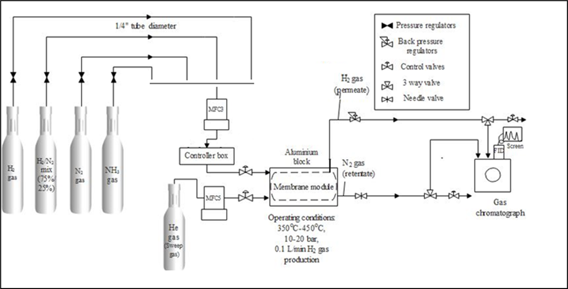

5. Clean-up, decontamination, and waste disposal
Identify the designated work area(s) and the necessary decontamination after completion of work. Identify and list all hazardous waste to be generated and appropriate disposal procedures. Include liquid and solid waste as well as gases and fumes vented out of the reaction system.
6. Special handling procedures, transport, and storage requirements
Describe special handling and storage requirements for hazardous materials used. Identify the location where the materials are to be stored. Describe secondary containment requirements and other precautions for transport between laboratory rooms.
7. Emergency equipment and procedures
Item | Location
Eyewash / safety shower
First aid kit
Chemical spill kit
Fire extinguisher
Fire alarm manual pull station
Telephone
Other

Indicate the location of all safety equipment in the lab. The following is an example of procedures for potential incidents associated with the use of hydrogen and ammonia.
Emergency | What to Do
Gas Leak | - If H₂ and or NH₃ leaks out of the system and there is sufficient gas to trigger the sensors, the alarm panel will be activated. Level 1 alarm will activate the strobe light in your lab. Stop the experiment, close the gas cylinder and all other downstream valves. Turn on the inert gas and find where the leak is and fix it.  - If there is sufficient gas leaking to trigger the Level 2 alarm, the alarm panel will activate the strobe light in your lab and in addition, you will hear a voice warning that gas has been detected and you must evacuate the building. Stop what you are doing and immediately leave the building using the nearest stairway. Proceed to your designated assembly point and be ready to provide information to the emergency responders regarding the circumstances surrounding the gas leak.
If personnel inhaled Ammonia | - Call 911 to seek emergency medical help.  - Assist exposed person away laboratory and into an area with fresh air.  - Wait for emergency responder to arrive and take the person to the nearest emergency room.
If clothing catches on fire | - Stop, drop and roll to extinguish fire.  - Call 911 to get immediate medical treatment.
If solid or liquid chemicals spill | - Determine if it is a “major” or “minor” spill. Minor spills are well contained, able to be cleaned using available spill kit and clean-up would not require special PPE such as a respirator.  - Assist anyone who may have been contaminated or injured during the spill.  - Clean up minor spills using appropriate spill control equipment.  - Call 911, USC Police (777-4215) and EH&S (777-5269) for all major spills.  - Contain major spill with appropriate absorbent only if trained to do so and your safety is not compromised.  - Post “DO NOT ENTER” on entrance door and evacuate the area.  - Do not re-enter until Emergency Responders have cleaned up the spill and declare the area safe for reentry.
If skin or eyes is splashed with chemicals | - If needed, call 911 to seek emergency medical help.  - Assist exposed person away from the incident or source of exposure to the emergency shower (skin exposure) or eyewash (eye exposure). Do this only if able and personal safety is not compromised. Affected person must decontaminate using the nearest emergency shower/eyewash.  - Pull the safety shower lever to start the water flowing (or push the eyewash lever to start the water flowing).  - To wash off chemicals from your eyes, hold your eyes open to get the water under your eyelids.  - To decontaminate skin, remove all contaminated clothing and shoes to effectively wash chemicals off your body.  - Stay under the water for at least 15 minutes to wash off the chemicals.  - Report incident to _____________(supervisor and phone number).  - Seek follow-up medical treatment at the nearest clinic during normal business hours or the nearest emergency room after business hours.
Life-threatening emergencies | - Call 911.  - Provide dispatch the following information: your name and call back number, location of incident, material released, if known, or if there are any injured person and their location.  - Pull the nearest fire alarm.  - Exit the building using the nearest stairway.  - Proceed to designated assembly area.  - Provide information to emergency responders as able.
Facility malfunction (i. e., power outages, plumbing leaks, fume hood) | Call (803) 777-9675 to report and request work order.
If needing medical care due to injury at work (personnel compensated by USC only) | See Section 10 Attachments for procedures on how to obtain medical treatment for work-related injuries.  After seeking medical care, any injury or illness involving any of the following: death, amputation, loss of an eye, is expected to or results in a hospitalization, must be reported to EH&S at (803) 777-5269 and Buddy Harley at (803) 528-8191 within 24 hr.
Incident Reporting | Report all incidents to your Supervisor or Principal Investigator, then to EH&S by completing the incident report form once emergency response has been completed (i.e., Emergency Responders have declared the incident area “All Clear”, spill has been cleaned up, and necessary medical care has been initiated).

8. Training requirements
List the general and laboratory-specific training required for authorized users of this SOP. Remove items that do not apply.
Chemical and Lab Safety Training (EH&S, Teams)
Safe Use and Handling of Compressed Gases (EH&S, On-line)
Review of chemical safety data sheet (Lab PI)
Demonstrate proficiency on step-by step methodology including safety procedures (Lab PI)
Demonstrate proficiency on executing emergency response procedures (Lab PI)
Fire Safety (EH&S, In-person)
Add others
9. Review, Approval and Authorized Users
SOPs are reviewed and signed by the USC Chemical Hygiene Officer as applicable, approved and signed by the lab Principal Investigator, signed by the Author, and signed by all Authorized Users.

Approved by Principal Investigator: Printed Name, Signature and Date
Prepared by Author: Printed Name, Signature and Date

*Reviewed by EH&S Chemical Hygiene Officer: Printed Name, Signature and Review Date
* Review by the EH&S CHO and/or the Chemical Safety Committee is required for SOPS involving highly hazardous chemicals (solids and liquids that are acutely toxic and/or pyrophoric, gases that are flammable, corrosive, toxic, and pyrophoric), processes that use and/or generate highly hazardous chemicals, extreme heat and/or high pressure, and equipment the poses a severe risk of injury to users. SOP review by the EH&S CHO is optional for others that do not belong to the above categories of hazardous chemicals, equipment, and processes.

Authorized Users
I, an Authorized User of this Standard Operating Procedure for the Title of SOP, agree by signing below, that I have completed all required trainings listed in Section 8. I have read and understand the content of this SOP, and will follow all aspects of this SOP, including but not limited to the proper use of PPE, safe handling of hazardous materials, precautionary measures, methodology, emergency procedures, and other instructions. I agree that I have received lab-specific training on the safe use of hazardous material, equipment, and processes described in this SOP.

Printed Name | Signature | Date

NOTE: Additional prior approval is required for any deviation from this SOP. A new SOP is required for any major deviation.
10. Safety References and other Attachment
- List books, published papers, equipment safety manuals, webpages and others used as references in writing this SOP.
- Attach chemical safety data sheets.
- Attach schematic diagrams, and photographs of complex processes or set-ups.
- Attach the most current HR Procedures for Work-related Injuries. Download and print from https://www.sc.edu/about/offices_and_divisions/human_resources/docs/wc_procedures.pdf

